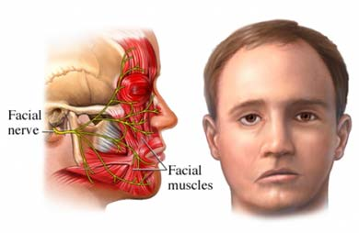
CASE STUDY – BELL’S PALSY
What is Bell’s Palsy?
Bell's palsy is a form of facial paralysis resulting from a dysfunction of the cranial nerve VII, which results in the inability to control facial muscles, usually on one side of the face. This condition comes on very rapidly, sometimes overnight, with no other symptoms. Although the cause of Bell’s palsy is unknown, it is thought that an inflammatory condition leads to swelling of the facial nerve. Nerve swelling and compression in the narrow bone canal are thought to lead to nerve inhibition and damage.
It is important to seek medical advice if this type of dysfunction occurs to eliminate conditions such as stroke, brain tumour or Lyme disease. If, however, no specific cause can be identified, following a medical assessment, the condition is known as Bell's palsy - the most common cause of acute facial nerve paralysis – with corticosteroids prescribed or the patient is told “it will heal in time”.
Case Study
An elderly gentleman in his 70’s was referred to my clinic in April 2012 with this very condition. Angelo just woke up one morning with paralysis to the left side of his face – he had the same condition 25 years earlier. It caused him difficulty in eating, especially as he had dentures. He was embarrassed, as anyone would be, and was keen to try anything to improve his condition. The friend who referred this man had suffered from Bell’s palsy and Bowen Therapy had helped in his recovery. He had a medical doctor check his condition and was told he could do nothing for him.
Angelo was very fit for his age and worked hard on his property, doing all the maintenance and mowing. He had slightly high blood pressure and elevated cholesterol for which he was prescribed Crestor.
On the first visit I noticed he had a very tight right scapula although the paralysis was on the left side of his face. I performed the basic relaxation moves, plus the Respiratory and TMJ procedures.
Following his first Bowen treatment he felt very relaxed, but a week later at his follow-up, his left-sided facial paralysis did not seem to have improved. He did however say that he felt well otherwise and his blood pressure was good. On this visit I repeated the previous procedures and added the North and Elbow/wrist procedures.
On the 3rd visit there was a slight improvement with less difficulty eating. Angelo was a little disappointment, but I reassured him he would have more improvement after the 3rd treatment. I continued the Bowen as before and added the Frozen Shoulder procedure. He felt great relief in his neck and shoulder tightness.
By the 4th visit, the paralysis appeared to be 90% improved and Angelo was extremely happy. The TMJ, Elbow/wrist and Frozen Shoulder procedures were repeated on this visit.
When Angelo came for his 5th visit the condition was completely resolved and this session was purely a ‘maintenance’ session. Angel enjoyed the sense of complete relaxation he received with each treatment and assured me he would tell all his friends and family about Bowen Therapy.

Maree Kendall –
Bowtech Works, Sydney, Australia
www.bowtechworks.com.au

